

$NOME
Software Manual

MAREL srl - FABRIANO (AN) – Italy
www.marelsrl.com

Summary

Marelinux
Marelinux is a live system bootable from a USB key based on Linux. It allows you to backup and to restore an hard disk. For every issue, contact the Marel support at software@marelsrl.com.
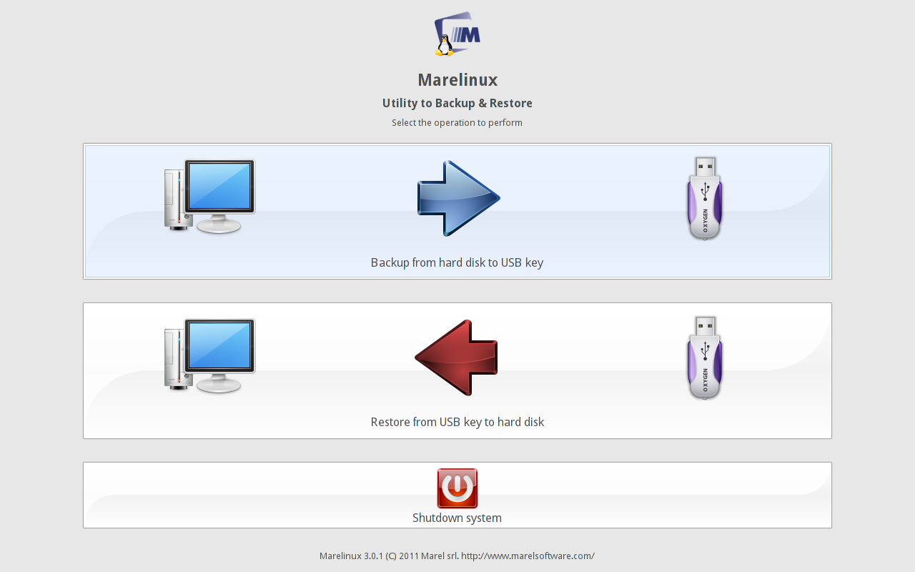

Backup
Select Backup from hard disk to USB key button to start the backup of your hard disk.
On the next window, select the hard disk to backup. If the selected disk contains more partitions, Marelinux will copy all of them.
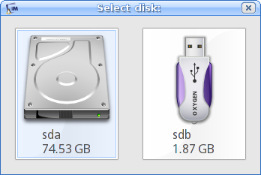
Now enter a name for the disk image to create. We suggest you to save the file under the marelinux directory (present on the USB key).
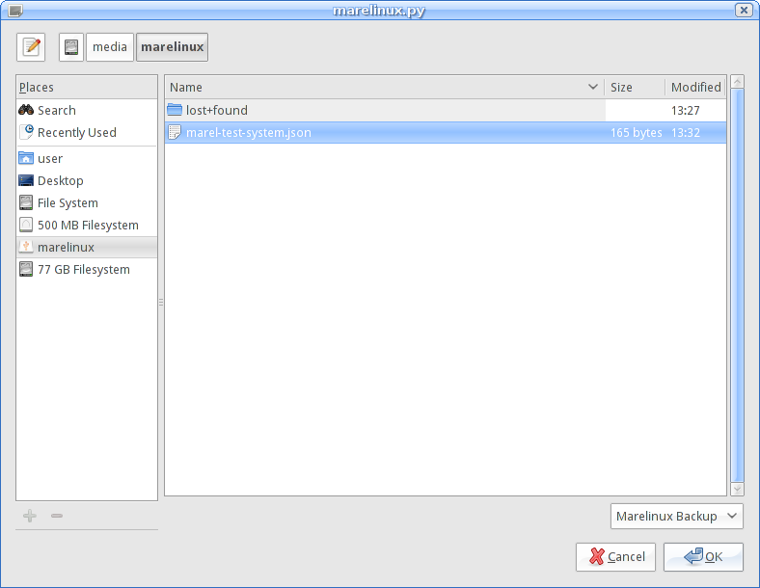
In the next step, Marelinux starts the backup of the entire hard disk. When it finish, the button Close will be enabled.
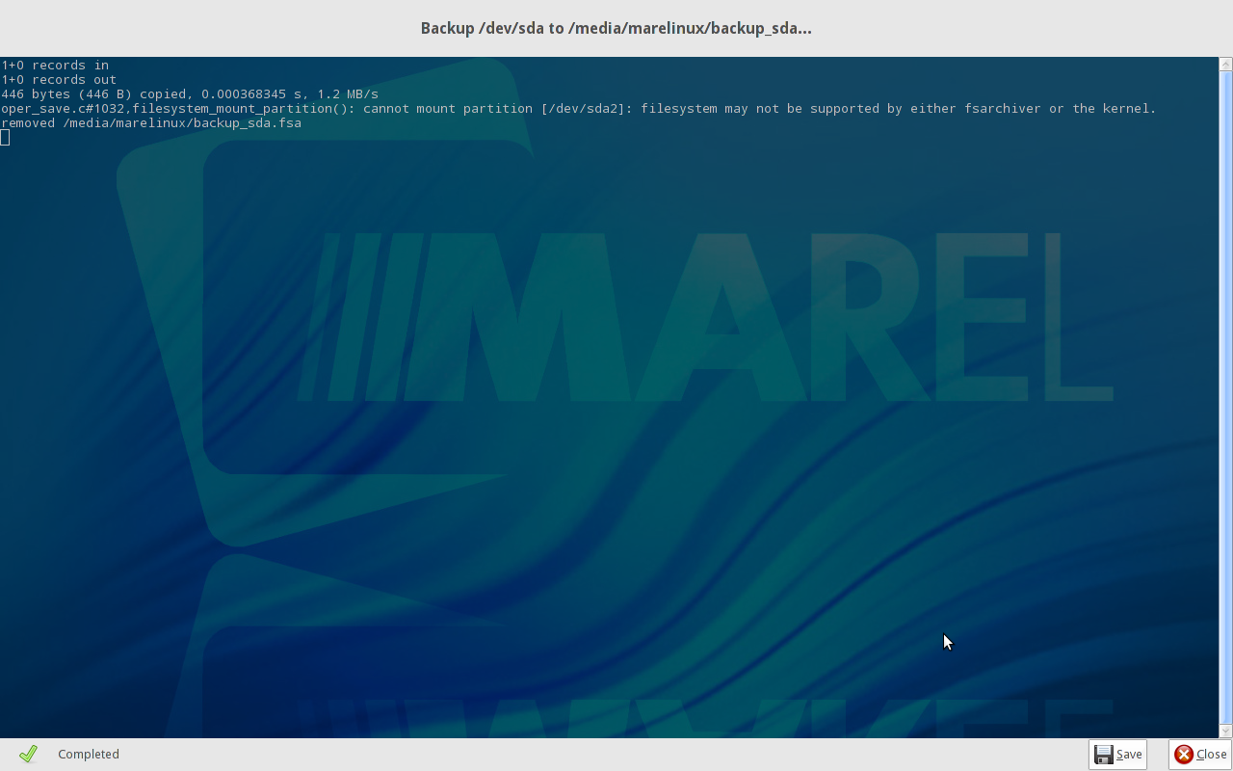

Restore
Select Restore from USB key to hard disk button to start the restore of your hard disk.
On the next window, select the file with the image of your disk. This file must be created with the same version of Marelinux.
Now select the hard disk where to restore the previous image.
In the next step, Marelinux starts the restore of the entire hard disk. When it finish, the button Close will be enabled.

Shutdown
Once you have completed all operations, you can halt your computer pressing the Shutdown system button. Confirm the operation pressing Ok in the next window.


