

$NOME
Manuale Software

MAREL srl - FABRIANO (AN) – Italy
www.marelsrl.com

Indice generale

MarelEOLTs
MarelEOLTs is an application for acquiring and processing data sampled from different devices, for reading electrical and physical quantities. One or more test stations can be defined in the software. The software is made up of three programs, one for managing the system configuration Configuration Management, one for managing the archive Archive Management and finally Station Management for carrying out the tests .

Using the program : Configuration Management
Let's start by seeing the operation and use of the Configuration Management program, for configuring the system so that the other programs can communicate correctly with each other. When the program starts without any active configuration, it will be asked you to create an administrator account, without which it will be no possible to configure the system. You can cancel the request by pressing the Cancel button and proceed to the main screen which will be this:
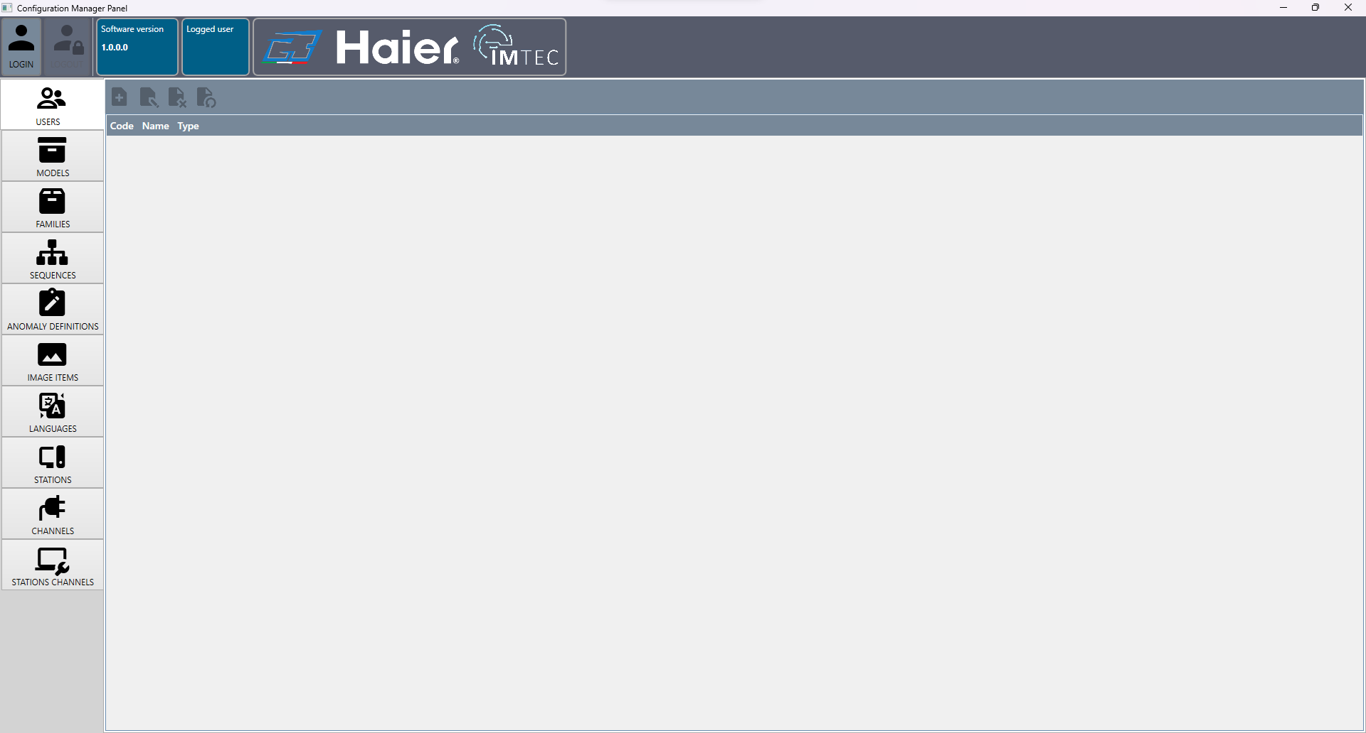
All the features for each tab in the program are described below.

Users
The Users window is used to create, modify and disable users. The screen is as follows:
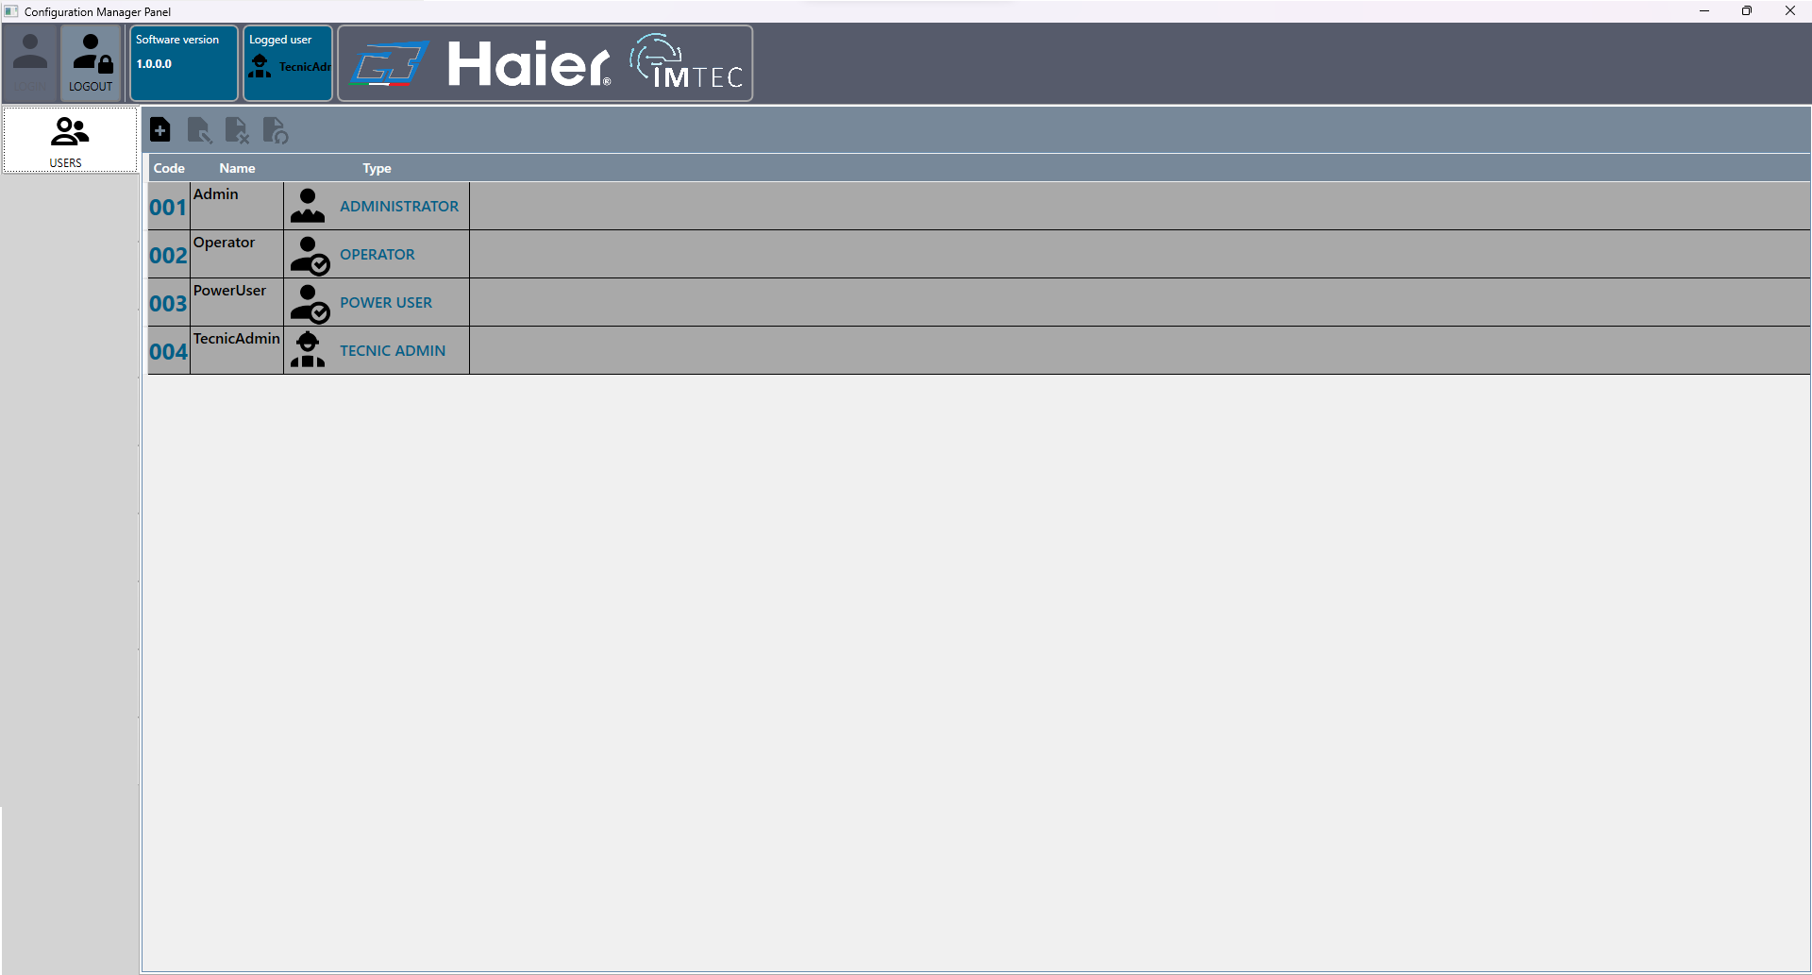
Below is the function of the toolbar buttons :
Icon | Key | Command
 | New user | Open the window to create a new user
 | Modify user | Open the window to create a new user with the fields already filled in and the possibility of modifying them
 | Set the user as deleted | If the user is set as deleted, it will no longer be possible to use it until it is re-enabled from an administrator or technical admin account
 | estore account | If the account is set to deleted, this will restore it and it can be used again
First we should log in by pressing the button Loginand since it is the first start, and having canceled the initial request to create an account as per the previous instructions, we should now do it via the following screen:
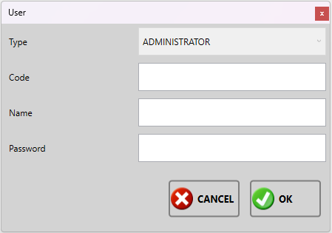
It will be necessary , specify the following data :
- Type : type of account, at first start it will only be possible to use the administrator;
- Code : numeric code to use to log in;
- Name : name of the operator who will use this account or a description of the account type;
- Password : password to log in, it is not mandatory to specify it;
Confirm the creation of the user by clicking on the button OK, or cancel the operation by clicking the button Cancel.
The types of accounts that can be created are in sequence from highest to lowest privileges : Tecnic admin , Administrator, Power user e Operator Below we see the difference in privileges for each type of account:
Funzioni Tabs | Tecnic admin |  | Administrator |  | Power user |  | Operator
 | Edit | View | Edit | View | Edit | View | Edit | View
Users | x | x | x | x |  | x |  | x
Models | x | x | x | x |  | x |  | x
Families | x | x | x | x |  | x |  | x
Images | x | x | x | x |  | x |  | x
Sequences | x | x | x | x |  | x |  | x
Anomaly definition | x | x | x | x |  | x |  | x
Image items | x | x | x | x |  | x |  | x
Languages | x | x | x | x | x | x | x | x
Stations | x | x
Channels | x | x
Station channels | x | x

Models
Click on the Models  button to access the following screen :
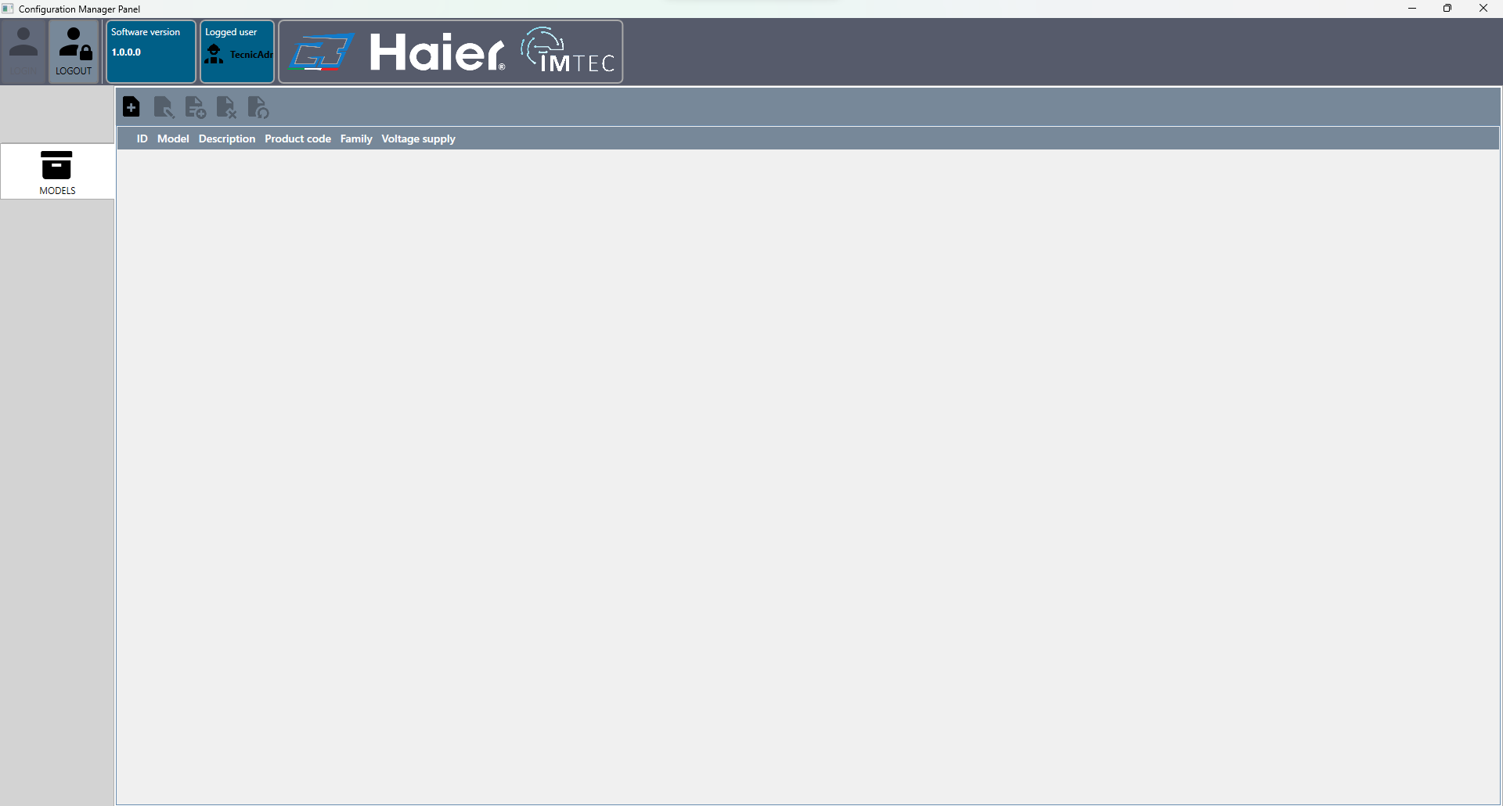
Below is the function of the toolbar buttons :
Icon | Key | Command
 | New model | Open the window to create a new model
 | Model Modify | Opens the Model creation window but the fields are already filled in and can be modified
 | Model copy | Copies the selected model and opens the model creation window with the fields already filled in and the possibility to modify them
 | Set the model as deleted | The model is set as deleted and cannot be used until you restore it
 | Model Restore | If the model is set as deleted this will restore it and it can be reused

New Model
To create a template, click on the icon and fill in the fields on the following screen: :
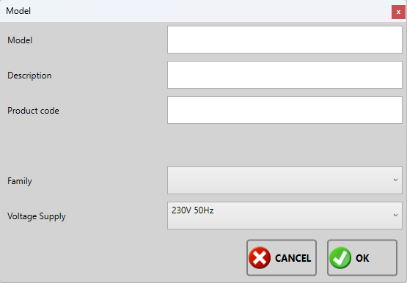
After it will be necessary to specify the following data :
- Model : text field to define the model (Es. M001);
- Description : Text field to insert a description of the model (Es. new generation);
- Product code : Text field to insert the product code (Es. 0123456789);
- Family : use the drop-down menu to select the family to which the product belongs (Es. F001);
- Votlage Supply : use the drop-down menu to select the which voltage use the product (Es. V230Hz50);
Confirm the creation by pressing the OK key, or cancel the creation by pressing the Cancel key.
Once the new model has been created it will appear on the main window:
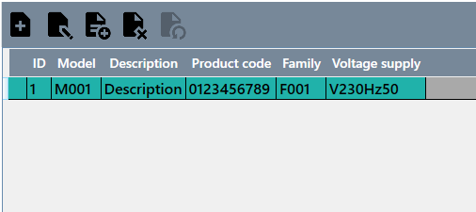

Model modify
To modify an already created template, select it from the list and click on the icon to access the same creation screen with the difference that the fields will already be filled in:
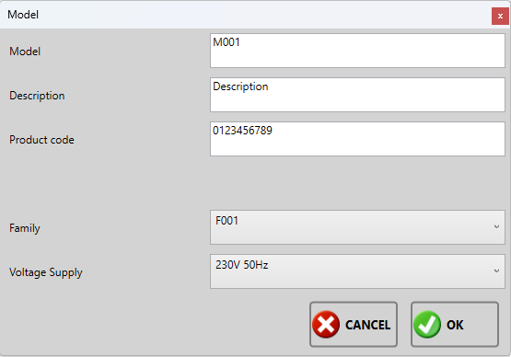
Confirm the changes by pressing the OK key or the Cancel key to cancel them.

Copy the model
To copy an already created model, select it from the list and click on the icon to access the same creation screen with the difference that the fields will already be filled in except for the template field since that field must be unique. Confirm the copy by pressing the OK key or the Cancel key to cancel it.

Delete Model
To set a model as deleted, select it from the list and click on the icon after deletion a trash can icon will appear next to the model as shown below following :
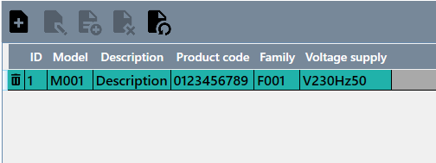

Restore model
To restore a deleted model, select it from the list and click on the icon

Family
Click on the Families button to access the following screen:
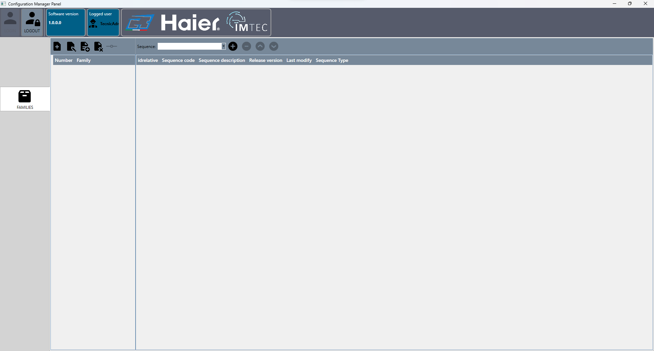
The window is divided into two parts, the part on the left manages creation, modification, deletion and confirmation of modifications. The part on the right manages which sequences to associate with the family.
Below is the function of the toolbar buttons:
Icon | Key | Command
 | New family | Opens the window to create a new family
 | Edit Family | Opens the family creation window but the fields are already filled in and can be modified
 | Copy Family | Copies the selected family and opens the family creation window with the fields already filled in and the possibility to modify them
 | Delete family | The family is eliminated
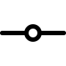 | Confirm changes | Press this button to confirm the changes made to the sequence list associated with the family

New Family
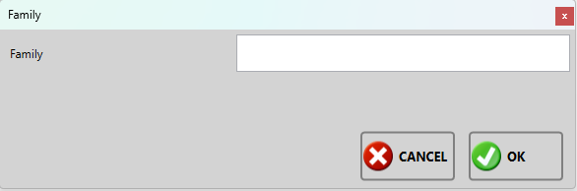
To create a family, click on the icon and fill in the fields on the following screen:
It will therefore be necessary to specify the following data:
- Family : text field to name the family (Ex. F001);
Confirm the operation by pressing the OK button.

Edit family
To modify an already created family, select it from the list and click on the icon to access the same creation screen with the difference that the fields will already be filled in.
Confirm the changes by pressing the OK key or the Cancel key to cancel them.

Delete family
To delete the family, select it from the list and click on the icon and confirm its deletion by pressing the Yes button on the next screen, or No to undelete.
 | A family associated with a model cannot be deleted

Confirm changes
Click on the button to confirm the changes made to the list of sequences in the right panel. If you do not confirm the changes made, they will not be saved.

Family Sequence
Below is the function of the toolbar buttons:
Icon | Key | Command
Menu a tendina | Select sequence | It opens a drop-down menu with all the created sequences that you can select
 | Add Sequence | Associate the selected sequence with the family
 | Remove Sequence | Removes the sequence selected in the list from the family
 | Move sequence to | Move the selected sequence in the list one slot higher
 | Move sequence down | Move the selected sequence in the list one slot lower
Once a sequence has been associated with the family, it will be displayed on the list as in the screen below:
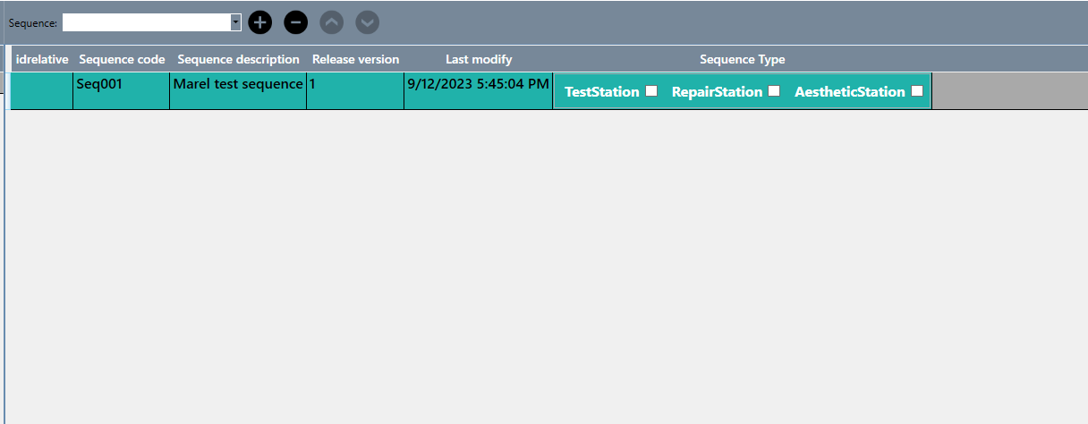
For each sequence added you can select the type of sequence by selecting the square next to the type. The type of sequence is related to the type of station, in this configuration we have three models:
- Test station
- Repair Station
- Aesthetic station
After setting these options you will need to click on the key confirm changes, to save them. Otherwise, if no option is selected, the sequence will not be executed during testing.
A station configured as test station will execute in the list of sequences only those where test station has been selected, so we could have a generic family that can be used in different test stations.

Sequences
Click on the key Sequenze to access the following screen :
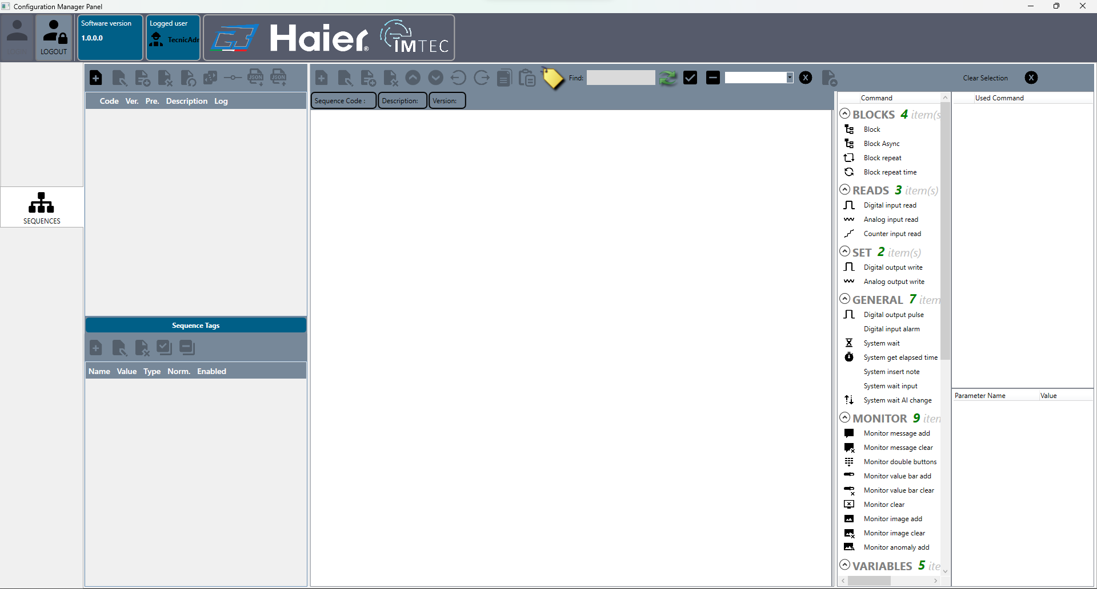
We divide the window into five sections so that we can see how each part works individually:
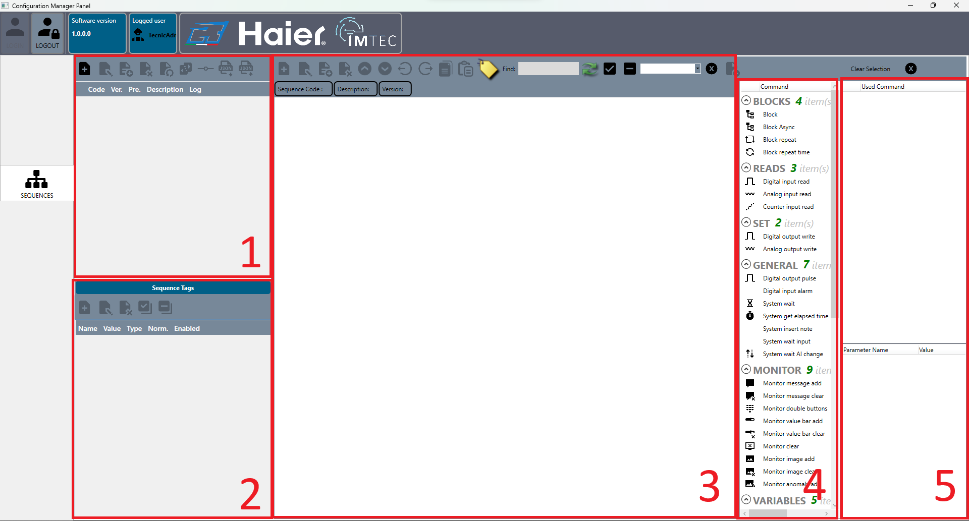

Sequence management (1)
Di seguito la funzione dei tasti della toolbar :
Icon | Key | Command
 | New sequence | Opens the window for creating a new sequence
 | Edit Sequence | Opens the sequence creation window, but the fields are already filled in and can be edited
 | Copy sequence | Copies the selected template and opens the sequence creation window with the fields already filled in and the possibility to modify them
 | Set the sequence as deleted | The sequence is set as deleted and cannot be used until it is restored
 | Restore Sequence | Restores the sequence and removes the deleted status.
 | Create new version of sequence | If the sequence has been confirmed as final, create a version of it in state
 | Confirm sequence as final | If the sequence is in pre-release status, it is confirmed as final and can no longer be modified
 | Export sequence to .json file | Export the selected sequence to a .json file
 | Import sequence from .json file | Import the sequence from a .json file

New Sequence
To create a new sequence click on the icon to access the following screen:
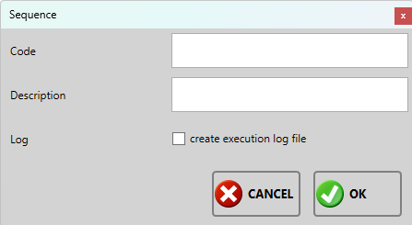
It will be necessary specify the following data:
- Code: text field, sequence code, the code is unique;
- Description : text field to insert a description of the sequence;
- Log: selective field, selecting the option creates a text file at the end of the sequence execution;
Confirm the creation by pressing the OK key, or cancel the creation by pressing the Cancel key.

Edit sequence
To modify an already created sequence, select it from the list and click on the icon to access the same creation screen with the difference that the fields will already be filled in. However, the code cannot be modified to avoid losing the integrity of the data.
Confirm the changes by pressing the OK key or the Cancel key to cancel them.

Copy sequence
To copy an already created sequence, select it from the list and click on the icon to access the same creation screen with the difference that the fields will already be compiled, it is necessary to modify the sequence code because that is unique.
Confirm the copy by pressing the OK key or the Cancel key to cancel it.

Delete sequence
To delete a sequence, select it from the list and click on the icon and confirm its deletion by pressing the Yes Key on the next screen, or No to undelete. The sequence is not totally deleted but marked as deleted. You can create another sequence with the same code, however the deleted sequence cannot be restored until the new sequence with the same code is active.
<Important note>Only one sequence can be active and the versions of it with the same code , but two different sequences must necessarily have different codes</note>

Restore Sequence
Select the sequence from the list and click on the icon to restore it. The sequence is restored only if another one has not been created with the same code.

Create new version
Click on the icon to create a new editable version of the sequence. Once a sequence has been confirmed as definitive it can no longer be modified by any user, the only way is to create a new version and this increases the value of the version going from 0 to 1, from 1 to 2 and so on .

Confirm final version
To make a sequence definitive, click on the icon. Making a sequence definitive means preventing any user from making further changes to it. If you want to modify it, you need to create a new version of it.

Export/import sequence to .json file
Click on the icon to export the selected sequence to a .json file or click on the icon to import a sequence from a .json file

Sequence tag management(2)
In this window we manage the tags via the toolbar. Tags are used in sequence commands, which we will see in the next chapter, as numeric or text comparison.
Below is the function of the toolbar buttons:
Icon | Button | Command
 | New tag | Opens the window for creating a new tag
 | Edit Tags | Opens the tag creation window, but the fields are already filled in and can be edited
 | Delete tag | Delete the selected tag from the list
 | Enable all | Enable normalization of all tags
 | Disable all | Disables normalization of all tags

Nuovo tag
To create a new tag , click on the icon to open the following screen :
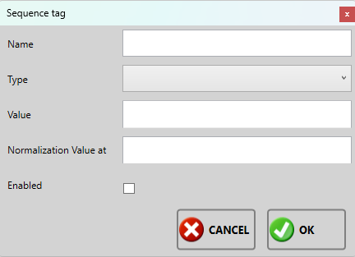
It will be necessary , specify the following data :
- Name : text field, tag name;
- Type : selective field, choose between numeric or text tag;
- Value: text field, sets the value of the tag, if numeric it is managed as a number otherwise as a string;
- Normalization of value a: numeric field, for normalization of values;

Edit tag
To edit an already created tag, select it from the list and click on the icon to access the same creation screen with the difference that the fields will already be filled in.
Confirm the changes by pressing the OK key or the Cancel key to cancel them.

Delete tag
To delete a tag, select it from the list and click on the icon and confirm its deletion by pressing the Yes button on the next screen, or No to undelete.
<important note>Deleting a used tag in a command, makes the command incomplete and the process will fail during its execution.</note>

Enable/disable all
Click on the icon to enable normalization of all tags or click on the to disable normalization of all tags. The tag values can be normalized to the voltage of the normalized value, for example by having a tag with name N1, value 0.3 of numeric type normalized to 220, it means that during the process when we are going to use this tag, the value 0.3 given at 220 volts, it is related to the current voltage which could perhaps vary to 218 or 230 so the limit remains consistent with the current.

Sequence command management (3)
In this window we manage the commands added to the sequence.
Below is the function of the toolbar buttons:
Icon | Key | Command
 | New command | Opens the window for creating a new command
 | Edit command | Opens the command creation window, but the fields are already filled in and can be modified
 | Copy command | Copy the selected command by creating another command within the same level
 | Delete command | Delete the selected command
 | Move up | Move the command one slot higher, always remaining in the same level
 | Move down | Move the command one slot lower, always remaining in the same level
 | Include command | Includes the command when executing the sequence
 | Exclude command | Excludes the command while executing the
 | Copy selected blocks | Copy all selected blocks
 | Paste Selected Blocks | Pastes the selected blocks immediately after the selected block
 | Move command label only | Click to enable moving the label between one command and another. The label is only moved in commands on the same level
Text box | Find command | Highlights in green all the commands that have what you write in the text box
 | Update list | Update search list
 | Select all blocks | Select all blocks in the sequence
 | Deselect all blocks | Deselects all blocks in the sequence
Drop-down menu | Select version | Selects other versions of the sequence and opens it on the same page by dividing it in two to compare different versions
 | Remove version selection | Closes the open page with the sequence version
 | Import the selected version | Copies the selected version of the sequence, into the main sequence

New command
To create a new command click on the icon or drag it from the menu(5) to access the following screen:
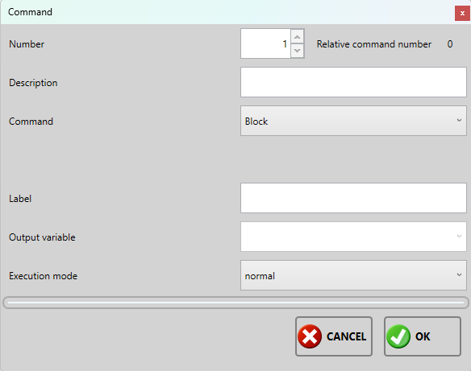
It will therefore be necessary to specify the following data:
- Number : numeric field indicates the index of the command;
- Description : text field, enter the description of the command visible in the list by default takes the type of command selected as description;
- Command: selective field, select from the list which type of command to insert, each command has a further list of parameters which we see in the commands section;
- Label: text field, the label is a label that appears next to the command to make it immediately visible in the list;
- Output variable: text field, if the command provides a result this is saved in the inserted variable;
- Execution mode: select the type of command execution between normal or excluded;
Once this part has been completed, confirm the creation of the command by clicking on the OK button or cancel the operation by clicking on the Cancel button.

Edit command
To modify the command, click on the icon, it opens the same creation window but with the fields filled in. It is possible to change the command description, the command execution and the command parameters. Confirm the changes by clicking on OK or cancel the operation by clicking on Cancel.

Copy command
To copy the selected command click on the icon, modify any parameters and confirm the copy by clicking on the OK button or cancel it by clicking on the Cancel button.

Delete command
Click on the icon to delete the selected command. The action is permanent and the deleted command cannot be recovered.

Move command up/down
Each command can be moved one slot higher by clicking on the button, or one slot lower by clicking on the button in the limit of the level of branching in the sequence tree. In the next image we have an example of a sequence with 4 levels, each command can only be moved within the same level:
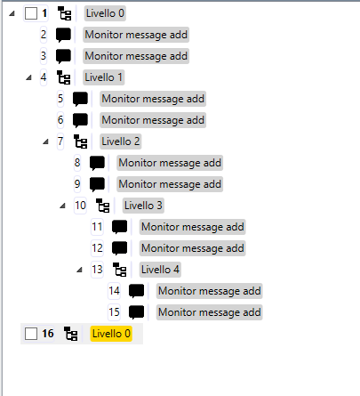

Include/exclude command
To speed up the exclusion or inclusion of a command in the sequence we can use these two keys, to include a command click on the icon , to exclude a command click on the icon . Including and excluding is simply changing the execution type of the command more quickly, instead of having to click on the command and then having to click on the edit button and then changing the execution type.

Copy/paste selected blocks
Select the blocks you want to copy and click on the | icon. To paste the copied blocks, select a block in the sequence or another sequence and click on the icon. Pasted blocks are placed immediately after the selected one.

Move label command
Click on the icon to enable moving the label between commands at the same level. After enabling this function, move the label up or down with the same keys used to move the controls.

Find command and update list
In the text field, for each letter inserted, the commands that have that letter are highlighted in green. The icon was used in the past, since previously it was necessary to enter the text and then click the icon to highlight the commands, but now the search is done by each letter entered and this feature is deprecated.

Select/deselect blocks
To select all the blocks at once, click on the icon. To deselect all blocks click on the icon.

Version
The sequence you just created is in a preview state. In this state it is possible to modify the sequence, add commands, remove them and modify them. Once confirmed as definitive, the sequence can no longer be modified and its version increases. If the sequence has multiple versions these can be retrieved and browsed via the drop-down menu.

Import version
Click on the icon to overwrite the preview sequence with one of the past versions selected from the drop-down menu.

Commands (4)
Below is the list of commands, their functions and parameters, the parameters description, command, label, output variable and execution mode are shared in all commands so they are described only in the initial blocks to avoid repetitions.

Blocks
Block: Basic block, where you can add other commands.
Parameters | Description
Description | Block Description
Command | Selected command type
Label | Label visible next to block on display tree
Output variable | The result of the command, if expected, is assigned to the variable written in this field
Running Mode | Sets the command execution mode if normal or excluded
Asynchronous block: Asynchronous basic block, where you can add other commands that run in parallel to the main sequence.
Parameters | Description
Description | Block Description
Command | Selected command type
Label | Label visible next to block on display tree
Output variable | The result of the command, if expected, is assigned to the variable written in this field
Running Mode | Sets the command execution mode if normal or excluded
Repeat block: Basic block with repetitions, where you can add other commands.
Parameters | Description
Description | Block Description
Command | Selected command type
Label | Label visible next to block on display tree
Output variable | The result of the command, if expected, is assigned to the variable written in this field
Running Mode | Sets the command execution mode if normal or excluded
Repetitions | Sets how many times to execute commands within the
Test Mode* | Sets the mode with which to exit the repetition
Timed repeat block: Basic block with repetitions, where you can add other commands.
Parameters | Description
Description | Block Description
Command | Selected command type
Label | Label visible next to block on display tree
Output variable | The result of the command, if expected, is assigned to the variable written in this field
Running Mode | Sets the command execution mode if normal or excluded
Timer | Set in seconds, how long the block, and any subcommands, must run
Test Mode* | Sets the mode with which to exit the repetition
*Test Mode : No test, commands are executed normally until the block completes. All OK, the commands are executed normally and must all be successful otherwise the block will fail and also the sequence. First OK, the commands are executed until there is a positive result, at the first positive result the block is completed and any commands not executed will not be executed and we move on to the next block in the sequence. Timeout, commands execute normally until the block completes.

Readings
Read digital input: Reads a digital input configured in the system.
Parameters | Description
Input Channel | Select the channel you want to read from the drop-down menu
Result value | Select, not set if you do not want to assign the result, on if the channel signal should be high or off if the signal should be low
Not ok, stop | If the option is enabled, the result of the command is checked if it is correct with the result value. If it doesn't go well, the command goes into error and interrupts the sequence
Ok, jump to | Select from the drop-down menu the label of a command to execute if the result is ok. All commands between the two will not be executed
Error code | Select the error code to assign to the command from the drop-down menu
Read analog input: Reads an analog input configured in the system.
Parameters | Description
Input channel | Select from the drop-down menu the channel you want to read
Minimum value | Select from the drop-down menu the tag with the minimum value
Maximum value | Select from the drop-down menu the tag with the maximum value
Not ok, stop | If the option is enabled, the result of the command is checked to ensure that it is appropriate with the result value. If it doesn't go well, the command goes into error and interrupts the sequence
Ok, jump to | Select from the drop-down menu the label of a command to execute if the result is ok. All commands between the two will not be executed
Error code | Select from the drop-down menu the error code to assign to the command
Time(ms) | Sets how long to read the channel value
Reading mode* | Sets how to read the values from the channel
Reference channel | Set the reference channel in case it is necessary to process the read value based on voltage, frequency or current and save the value of that channel too
Additional Values | Saves all reference channels set in the system
*Reading mode: Last, takes the last read value for the test. Average, performs an average of all the values read and takes the average to do the control. Maximum, takes the maximum value among those read to perform the check. Minimum, takes the minimum value read to perform the check.

Writings
Write digital output: Writes a digital output.
Parameters | Description
Output channel | Select the channel you want to write from the drop-down menu
Value | Select it to write ON, do not select it to write OFF
Error code | Select from the drop-down menu the error code to assign to the command
Write analog output: Writes an analog output.
Parameters | Description
Output channel | Select from the drop-down menu the channel you want to write
Value | Select the numerical value you want to write
Error code | Select from the drop-down menu the error code to assign to the command

General
Digital output pulse: lowers the signal of the selected channel to raise it after the set time
Parameters | Description
Output channel | Select the input channel to confirm a manual OK and continue executing the next command
Time(ms) | Set the wait duration in milliseconds
Error code | Select from the drop-down menu the error code to assign to the command
Digital input alarm : jumps to the selected label if the digital channel corresponds to the set value
Parameters | Description
Input channel | Select from the drop-down menu the channel you want to use
Result value | If selected it means that the channel must be in an open state, otherwise in a closed state
Error code | Select from the drop-down menu the error code to assign to the command
Final command label | Select the label of the command to execute if the condition occurs
Output channel | Select from the drop-down menu, the output channel
Value | Sets the value of the output channel
Wait system : Set a wait in the execution of the sequence
Parameters | Description
Time(ms) | Set the wait duration in milliseconds
Input channel OK | Select the input channel to confirm a manual OK and continue executing the next command
Input channel KO | Select the input channel to confirm a manual NOK and stop sequence execution
Not ok, stop | If the option is enabled, the result of the command is checked to ensure that it is correct with the result value. If it doesn't go well, the command goes into error and interrupts the sequence
Error code | Select the error code to assign to the
Calculate elapsed time : Calculates the time elapsed until this command and takes the command with the selected label as the starting point
Parameters | Description
From command label | Select the command label from which to calculate the time elapsed until this command
Wait for analog input (AI) status change: sets a wait state for a specific channel until its read value has changed by the set value
Parameters | Description
Time(ms) | Set the wait duration in milliseconds
Input channel | Select from the drop-down menu, the channel you want to use
Value | Set the reference value
Trigger Mode* | Sets how the state change is verified
Not ok, stop | If the option is enabled, the result of the command is checked to ensure that it is correct with the result value. If it doesn't go well, the command goes into error and interrupts the sequence
Error code | Select from the drop-down menu, the error code to assign to the command
*Trigger mode: Relative, the value read by the channel must increase at least by the set value, greater than or equal if the value read by the channel is greater or equal to the set value, less than or equal the value read by the channel must be less or equal to the set value.

Screen
Add message on screen: adds a message to display to the operator
Parameters | Description
Operator message | Sets the message to appear to the operator
Variable | Select the variable to be shown together with the message (not mandatory)
Variable text format | {0} is replaced with the value of the variable
Clear messages on screen: removes either all or just the last message viewed
Parameters | Description
Clean all | If selected, it removes all the messages that appeared on the screen, otherwise only the last one added
Double button screen: adds a message to the screen and the operator must interact with the message by giving ok or ko
Parameters | Description
Operator message | Sets the message to appear to the operator
Text on OK button | Set the text displayed on the confirm button
Text on the KO button | Sets the text displayed on the button to not confirm
Time(s) | Set in seconds, how much time the operator has to select OK or KO
Input channel for OK | Select the input channel to read to give OK
Entry channel for the KO | Select the input channel to read to KO
Not ok, stop | If the option is enabled, the result of the command is checked to ensure that it is consistent with the result value. If it doesn't go well, the command goes into error and interrupts the sequence
Error code | Select from the drop-down menu the error code to assign to the command
Add horizontal bar on the screen: adds a bar to the screen by linking it to a variable, displays a bar with the minimum and maximum value and the value of the variable varies on the bar in real time
Parameters | Description
Minimum value | Select from the drop-down menu the tag with the minimum value
Maximum value | Select from the drop-down menu the tag with the maximum value
Input variable | Set the variable to check
Variable text format | {0} is replaced with the value of the variable
Clear horizontal bar on screen: removes either all or only the last bar displayed
Parameters | Description
Clean all | If selected it removes all the bars visible on the screen, otherwise only the most recently added
Clear screen: removes everything visible on the screen, messages, bars.
Add image to screen: adds an operator message and an image
Parameters | Description
Operator message | Sets the message to appear to the operator
Image | Select an image from the drop-down menu of those created in the images section
Clean screen images: removes either all or only the last image displayed
Parameters | Description
Clean all | If selected it removes all images visible on the screen, otherwise only the most recently added
Add anomaly: displays the set image during the test phase and the possibility of adding previously created anomalies
Parameters | Description
Operator message | Sets the message to appear to the operator
Image | Select an image from the drop-down menu of those created in the images section

Variables
Test Boolean variable: performs a true or false test on the selected variable
Parameters | Description
Input variable | Set the variable to check
Result value | If selected, the result of the variable must be equal to true for the command to be ok, otherwise the result must be false for the command to be ok
Not ok, stop | If the option is enabled, the result of the command is checked to ensure that it is corresponding with the result value. If it doesn't go well, the command goes into error and interrupts the sequence
Ok, jump to | Select from the drop-down menu the label of a command to execute if the result is ok. All commands between the two will not be executed
Error code | Select from the drop-down menu the error code to assign to the command
Test variable value : performs a test on the value of the selected variable
Parameters | Description
Input variable | Set the variable to check
Minimum value | Select from the drop-down menu the tag with the minimum value
Maximum value | Select from the drop-down menu the tag with the maximum value
Not ok, stop | If the option is enabled, the result of the command is checked to ensure that it is corresponding with the result value. If it doesn't go well, the command goes into error and interrupts the sequence
Ok, jump to | Select from the drop-down menu the label of a command to execute if the result is ok. All commands between the two will not be executed
Ok, if it doesn't match | If enabled, it sets the result to OK when the read value is not between the minimum and maximum
Error code | Select from the drop-down menu the error code to assign to the command
Test variable value AND: performs a bitwise test based on the input variable and the set value
Parameters | Description
Input variable | Set the variable to check
Value | Value used for the bitwise AND operation
Not ok, stop | If the option is enabled, the result of the command is checked to ensure that it is corresponding with the result value. If it doesn't go well, the command goes into error and interrupts the sequence
Ok, jump to | Select from the drop-down menu the label of a command to execute if the result is ok. All commands between the two will not be executed
Ok, if it doesn't match | If enabled, it sets the result to OK when the read value is not between the minimum and maximum
Error code | Select from the drop-down menu, the error code to assign to the command
Compare variables: compare the first selected variable with the second, the interval is calculated only on the second variable
Parameters | Description
Input variable | Sets the variable to be monitored as the first comparison term
Comparison operator | From the drop-down menu, select the operator for the comparison, whether it must be equal to, greater than, greater than or equal to, less than or less than or equal to
Range +/- | Sets a range for the second comparison variable
Input variable | Sets the variable to be monitored as the second comparison term
Not ok, stop | If the option is enabled, the result of the command is checked to ensure that it is consistent with the result value. If it doesn't go well, the command goes into error and interrupts the sequence
Ok, jump to | Select from the drop-down menu the label of a command to execute if the result is ok. All commands between the two will not be executed
Ok, if it doesn't match | If enabled, it sets the result to OK when the read value is not between the minimum and maximum
Error code | Select the error code to assign to the
Difference between variables: Controls the difference of the first variable and the second variable and must be within the range if min and max are set or greater than the minimum if only the minimum is set or less than the maximum if only the maximum is set
Parameters | Description
Input variable | Set the variable to check as minuend
Input variable | Set the variable to check as subtracting
Minimum value | Select from the drop-down menu, the tag with the minimum value
Maximum value | Select from the drop-down menu, the tag with the maximum value
Not ok, stop | If the option is enabled, the result of the command is checked to ensure that it is consistent with the result value. If it doesn't go well, the command goes into error and interrupts the sequence
Ok, jump to | Select from the drop-down menu the label of a command to execute if the result is ok. All commands between the two will not be executed
Error code | Select from the drop-down menu, the error code to assign to the command

Devices
Read value from device: similar to reading the analog channel
Parameters | Description
Input Device | Select from the drop-down menu, the device from which to read
Minimum value | Select from the drop-down menu, the tag with the minimum value
Maximum value | Select from the drop-down menu, the tag with the maximum value
Not ok, stop | If the option is enabled, the result of the command is checked to ensure that it is corresponding with the result value. If it doesn't go well, the command goes into error and interrupts the sequence
Ok, jump to | Select from the drop-down menu, the label of a command to execute if the result is ok. All commands between the two, will not be executed
Ok, if it doesn't match | If enabled, it sets the result to OK when the read value is not between the minimum and maximum
Error code | Select the error code to assign to the
Time(ms) | Sets how long to read the channel value
Reading mode* | Sets how to read the values from the channel
Write value to device: Similar to the analog write command
Parameters | Description
Output Device | Select from the drop-down menu, the output device
Value | Set the value to write to the device
Error code | Select from the drop-down menu, the error code to assign to the command
Device Function Command: Send a command to a compatible device.
Parameters | Description
Device command | Select the command to send from the drop-down menu
Command parameters (separated by ; ) | Set the parameters of the command, each parameter must be divided by a ;
Minimum value | Select from the drop-down menu, the tag with the minimum value
Maximum value | Select from the drop-down menu, the tag with the maximum value
Accepted string value | Select from the drop-down menu, the string value that can be accepted as a response from the command
String comparison method | Select from the drop-down menu which comparison method to use
Not ok, stop | If the option is enabled, the result of the command is checked to ensure that it is corresponding with the result value. If it doesn't go well, the command goes into error and interrupts the sequence
Ok, jump to | Select from the drop-down menu the label of a command to execute if the result is ok. All commands between the two will not be executed
Ok, if it doesn't match | If enabled, set the result to OK when the read value is not between the minimum and maximum or the string does not match
Error code | Select from the drop-down menu, the error code to assign to the command

Security test
Insulation test
Parameters | Description
Safety device | Set the security device to use
Not ok, stop | If the option is enabled, the result of the command is checked to ensure that it is consistent with the result value. If it doesn't go well, the command goes into error and interrupts the sequence
Error code | Select from the drop-down menu the error code to assign to the command
PE Test
Parameters | Description
Safety device | Set the security device to use
Not ok, stop | If the option is enabled, the result of the command is checked to ensure that it is consistent with the result value. If it doesn't go well, the command goes into error and interrupts the sequence
Error code | Select from the drop-down menu, the error code to assign to the command
Functional test
Parameters | Description
Safety device | Set the security device to use
Not ok, stop | If the option is enabled, the result of the command is checked to ensure that it is consistent with the result value. If it doesn't go well, the command goes into error and interrupts the sequence
Error code | Select from the drop-down menu, the error code to assign to the command
Additional
Parameters | Description
Safety device | Set the security device to use
Not ok, stop | If the option is enabled, the result of the command is checked to ensure that it is consistent with the result value. If it doesn't go well, the command goes into error and interrupts the sequence
Error code | Select from the drop-down menu, the error code to assign to the command
High voltage AC test
Parameters | Description
Safety device | Set the security device to use
Not ok, stop | If the option is enabled, the result of the command is checked to ensure that it is consistent with the result value. If it doesn't go well, the command goes into error and interrupts the sequence
Error code | Select from the drop-down menu, the error code to assign to the command
Visual
Parameters | Description
Safety device | Set the security device to use
Not ok, stop | If the option is enabled, the result of the command is checked to ensure that it is consistent with the result value. If it doesn't go well, the command goes into error and interrupts the sequence
Error code | Select from the drop-down menu, the error code to assign to the command
Dispersion test
Parameters | Description
Safety device | Set the security device to use
Not ok, stop | If the option is enabled, the result of the command is checked to ensure that it is consistent with the result value. If it doesn't go well, the command goes into error and interrupts the sequence
Error code | Select from the drop-down menu, the error code to assign to the command
The additional parameters for the test are specified according to the safety device used, each parameter is already described in the command display

Aesthetics
Add anomaly: displays the image during the test phase and the possibility of adding anomalies to the selected boxes
Parameters | Description
Defects table | composed of 12 blocks, select the ones to which you want to add a defect during the testing phase, the others will not be visible if not enabled
Image | Select an image from the drop-down menu of those created in the images section

Quick Commands (5)
In the Quick Commands panel, all commands of the same type selected in section (4) used in other sequences are displayed. If this is dragged into the sequence, the fields already filled in based on the command taken are displayed in the channel creation panel. The parameters are displayed in the panel below.

Anomaly definitions
Click on the Anomaly definitions button to access the following screen:
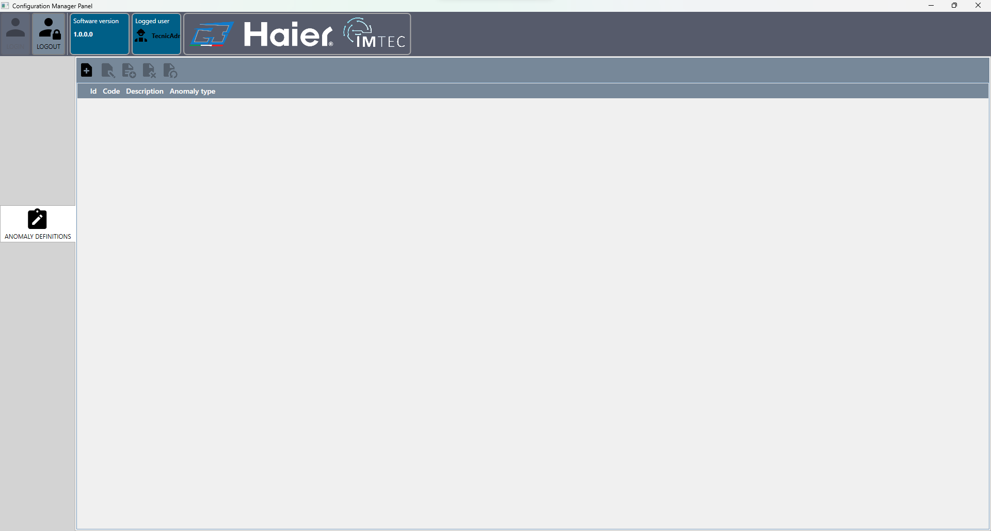
Below is the function of the toolbar buttons:
Icon | Button | Command
 | New anomaly | Opens the window to create a new anomaly
 | Edit anomaly | Opens the anomaly creation window but the fields are already filled in and can be modified
 | Copy anomaly | Opens the anomaly creation window but the fields are already filled in and can be modified to create a new one
 | Eliminate anomaly | Set the anomaly as deleted and it can no longer be used in sequence commands
 | Restore anomaly | Restore the anomaly and can be used again in sequence commands

New anomaly
To create an anomaly, click on the icon and fill in the fields on the following screen:
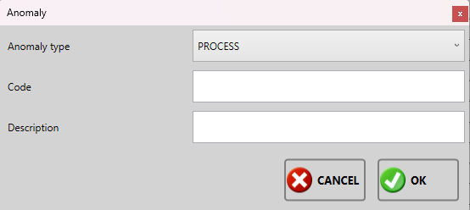
It will therefore be necessary to specify the following data:
- Type of anomaly: select the type from the drop-down menu between aesthetic, process, product and safety;
- Code : text field, enter a code for the anomaly;
- Description : text field, enter a description of the anomaly;
Confirm the operation by pressing the OK button or cancel it by clicking the Cancel button.

Edit anomaly
To modify an anomaly already created, select it from the list and click on the icon to access the same creation screen with the difference that the fields will already be filled in .
Confirm the changes by pressing the OK key or the Cancel key to cancel them.

Copy anomaly
To copy an anomaly already created, select it from the list and click on the icon to access the same creation screen with the difference that the fields will be already filled out.
Confirm the copy by pressing the OK key or the Cancel key to cancel it.

Eliminate anomaly
To set an anomaly as deleted, select it from the list and click on the icon after deletion a trash can icon will appear next to the item in the list.

Restore anomaly
To restore a deleted anomaly, select it from the list and click on the icon

Image items
Click on the Images items button to access the following screen:
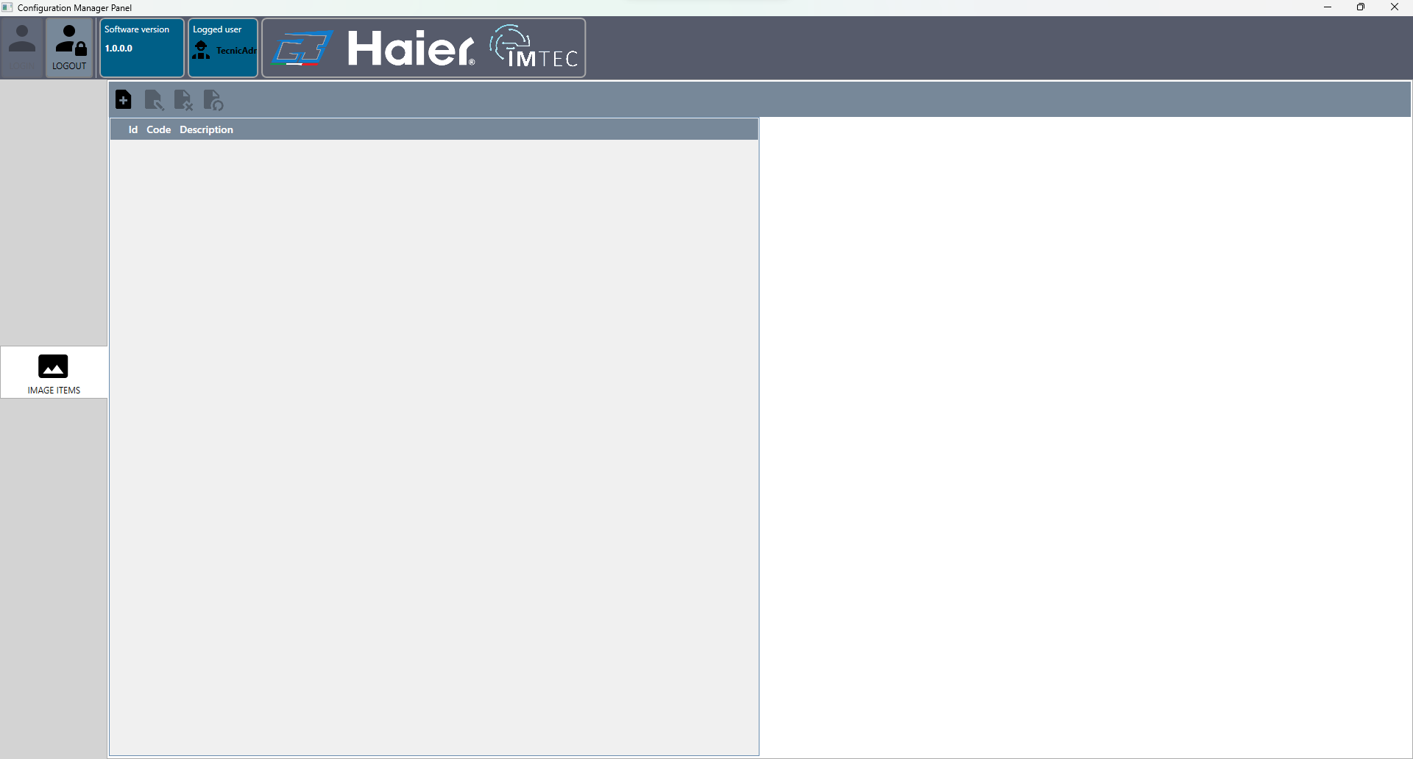
Below is the function of the toolbar buttons:
Icon | Button | Command
 | New image | Opens the window for creating a new image
 | Edit Image | Opens the image creation window but the fields are already filled in and can be modified
 | Set deleted | The image is set as deleted and cannot be used until it is restored
 | Restore Image | If the model is set as deleted this will restore it and it can be reused

New image
To create an image, click on the icon and fill in the fields on the following screen:
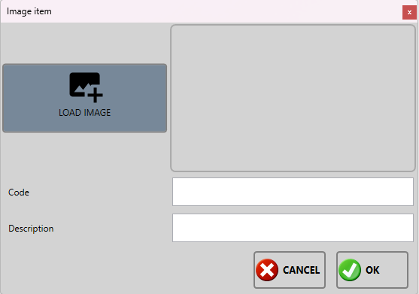
It will therefore be necessary to specify the following data:
- Load Image: button to select an image from your computer, once selected you will see the preview in the next box;
- Code : image code;
- Description : description of the image;
Confirm the operation by pressing the OK key or cancel the creation by pressing the Cancel key.

Edit image
To edit an image already created, select it from the list and click on the icon to access the same creation screen with the difference that the fields will already be filled in.
Confirm the changes by pressing the OK key or the Cancel key to cancel them.

Delete image
To set an image as deleted, select it from the list and click on the icon after deletion a trash can icon will appear next to the item in the list.

Restore image
To restore a deleted image, select it from the list and click on the icon

Languages
Click on the Languages button  to access the following screen:
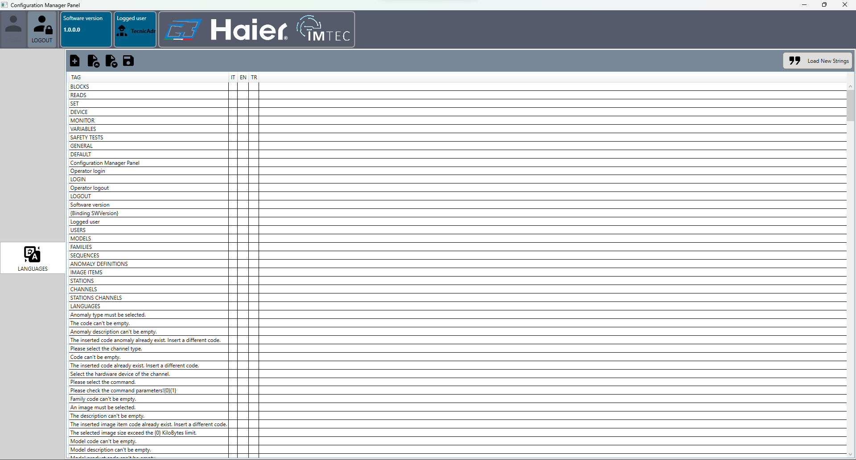
Below is the function of the toolbar buttons:
Icon | Button | Command
 | New language | Opens the window for adding a new code to identify a language
 | Import .po file | Import an external .po file to load the translations already made
 | Export .po file | Export the entire table and create a .po file
 | Save | Save changes made to each row/column
 | Upload new phrases/Tags | Adds, if there are, the strings found in the .pot file to the .po file to be translated
For language management we use .po files which are standard text files for this function. They can be opened with software such as notepad, notepad++ etc… To change the language of the program simply write the code of the language you prefer in the configuration file/>
The .pot file with the new strings is provided exclusively by Marel

New language
To create a new code for a language, click on the icon and fill in the only field on the following screen:
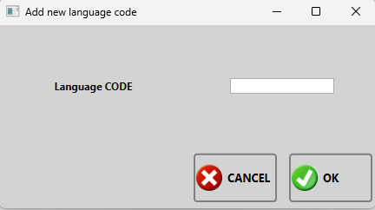
It will therefore be necessary to specify the following data:
- Language CODE: text field, identification code to select that translation;
Confirm the operation by pressing the OK key or cancel the creation by pressing the Cancel key.

Import .po file
To import an external .po file click on the Import button and select it via the window. The file that is imported creates a new language code if it is not already present in the language management and automatically imports all the translations that correspond to the TAG table.

Export .po file
Click on the Export .po file button to open the window and select the folder where you want to create the .po files for each created language. In our case by default we have IT,EN,TR which means that by exporting the table, an it.po, en.po and tr.po file are created for each code.
<important note>If the translations are not complete, the attached text fields will not be visible, and some program windows may be incomplete </note>

Load new TAGS
To load new sentences click on the Load new sentences button. The new sentences are present under the TAG column and it is necessary to request the updated file from Marel otherwise this function always reloads the same ones without updating anything.
Pressing the load new strings button does not overwrite the translations made

Stations
Click on the Stations button to access the following screen:
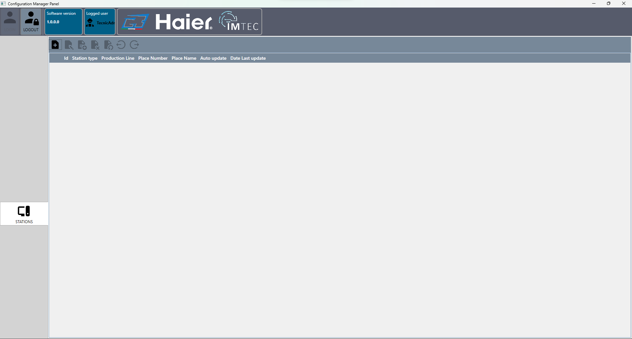
Below is the function of the toolbar buttons:
Icon | Button | Command
 | New station | Opens the window to create a new station
 | Edit station | Opens the station creation window but the fields are already filled in and can be modified
 | Copy station | Copies the selected station and opens the station creation window with the fields already filled in and the possibility to modify them
 | Delete station | Mark the station as deleted it cannot be used until it is restored
 | Restore Station | Restore deleted station
 | Disable station | Mark the station as disabled
 | Enable station | Rehabilitate the station

New station
To create a new station, click on the icon and fill in the fields on the following screen:
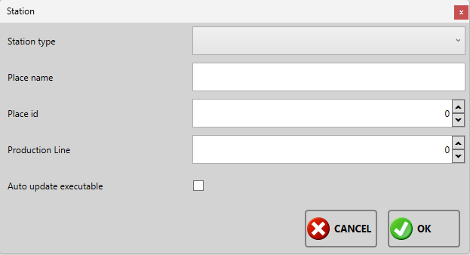
It will therefore be necessary to specify the following data:
- Station type : drop-down menu, to select the type of station, Test station,Repair station,Aesthetic station,;
- Place name : descriptive field, name of the station;
- Place id : numerical field incremental by 1, sets the station number;
- Production line : numeric field incremental by 1, sets the production line number;
- Auto update executable: selective field, if selected it sets that the station automatically updates its software when an update is present;
Confirm the operation by pressing the OK key or cancel the creation by pressing the Cancel key.

Edit station
To modify an already created station, select it from the list and click on the icon to access the same creation screen with the difference that the fields will already be filled in.
Confirm the changes by pressing the OK key or the Cancel key to cancel them.

Copy station
To copy an already created station, select it from the list and click on the icon to access the same creation screen with the difference that the fields will already be filled out.
Confirm the creation of a new station by clicking on the OK button or cancel the operation by clicking on the Cancel button.

Delete station
To set a station as deleted, if it is no longer present in the production line, select it from the list and click on the icon which will appear after deletion a trash can icon next to the station.

Restore station
To restore a deleted station and remove the deleted status, select it from the list and click on the icon.

Disable station
To disable a station press the icon , the disabled station will not receive any product to test on the production line.

Enable station
To re-enable a station press the icon , the disabled station will not receive any products to test on the production line.

Channels
Click on the Channels button  to access the following screen:
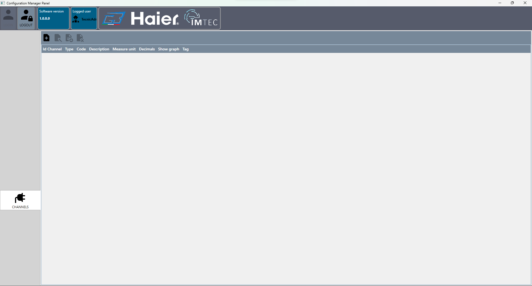
Below is the function of the toolbar buttons:
Icon | Button | Command
 | New channel | Opens the window for creating a new channel
 | Edit channel | Opens the channel creation window but the fields are already filled in and can be modified
 | Copy channel | Copies the selected channel and opens the channel creation window with the fields already filled in and the possibility to modify them
 | Delete channel | Delete the selected channel from the list
All created channels will be shared between created stations, so you need to go to Stations channels to properly configure the channels for each station.
<important note> The system is supplied already configured by Marel. </note>

New channel
To create a channel, click on the icon and fill in the fields on the following screen:
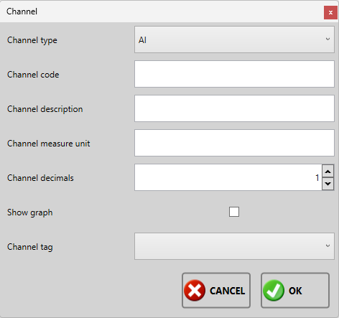
It will therefore be necessary to specify the following data:
- Channel type: selective field, select from the drop-down menu which type of channel to create, among AI, AO, CNT, CUSTOM, DEVICE IN, DEVICE OUT, DI, C, SAFETY;
- Channel code : text field, channel code;
- Channel description : text field, channel description;
- Channel measure unit : text field, channel measurement unit;
- Channel decimals : numeric field, number of decimal units to use and show;
- Show graph: selective field, if selected this channel will be visible on the graph during the test, the graph is accessible only to TECNIC ADMIN and ADMIN users;
- Channel tag: selective field, select from the drop-down menu the tag to associate with the channel between Sampling ampere, sampling voltage, sampling power, sampling frequency , this tag is used to set the channel as a reference channel if we need to use amperes, voltage, frequency or power in calculations and mathematical formulas;
Confirm the operation by pressing the OK key or cancel the creation by pressing the Cancel key.

Edit channel
To edit an already created channel, select it from the list and click on the icon to access the same creation screen with the difference that the fields will already be filled in.
Confirm the changes by pressing the OK key or the Cancel key to cancel them.

Copy channel
To copy an already created channel, select it from the list and click on the icon to access the same creation screen with the difference that the fields will already be filled out.
Confirm the creation of the new channel by pressing the OK button or cancel the operation by clicking on the Cancel button.

Delete channel
To delete a channel, select it from the list and click on the icon and confirm its deletion by pressing the Yes button on the next screen, or No to undelete.

Stations channel
Click on the Stations channel button to access the following screen:
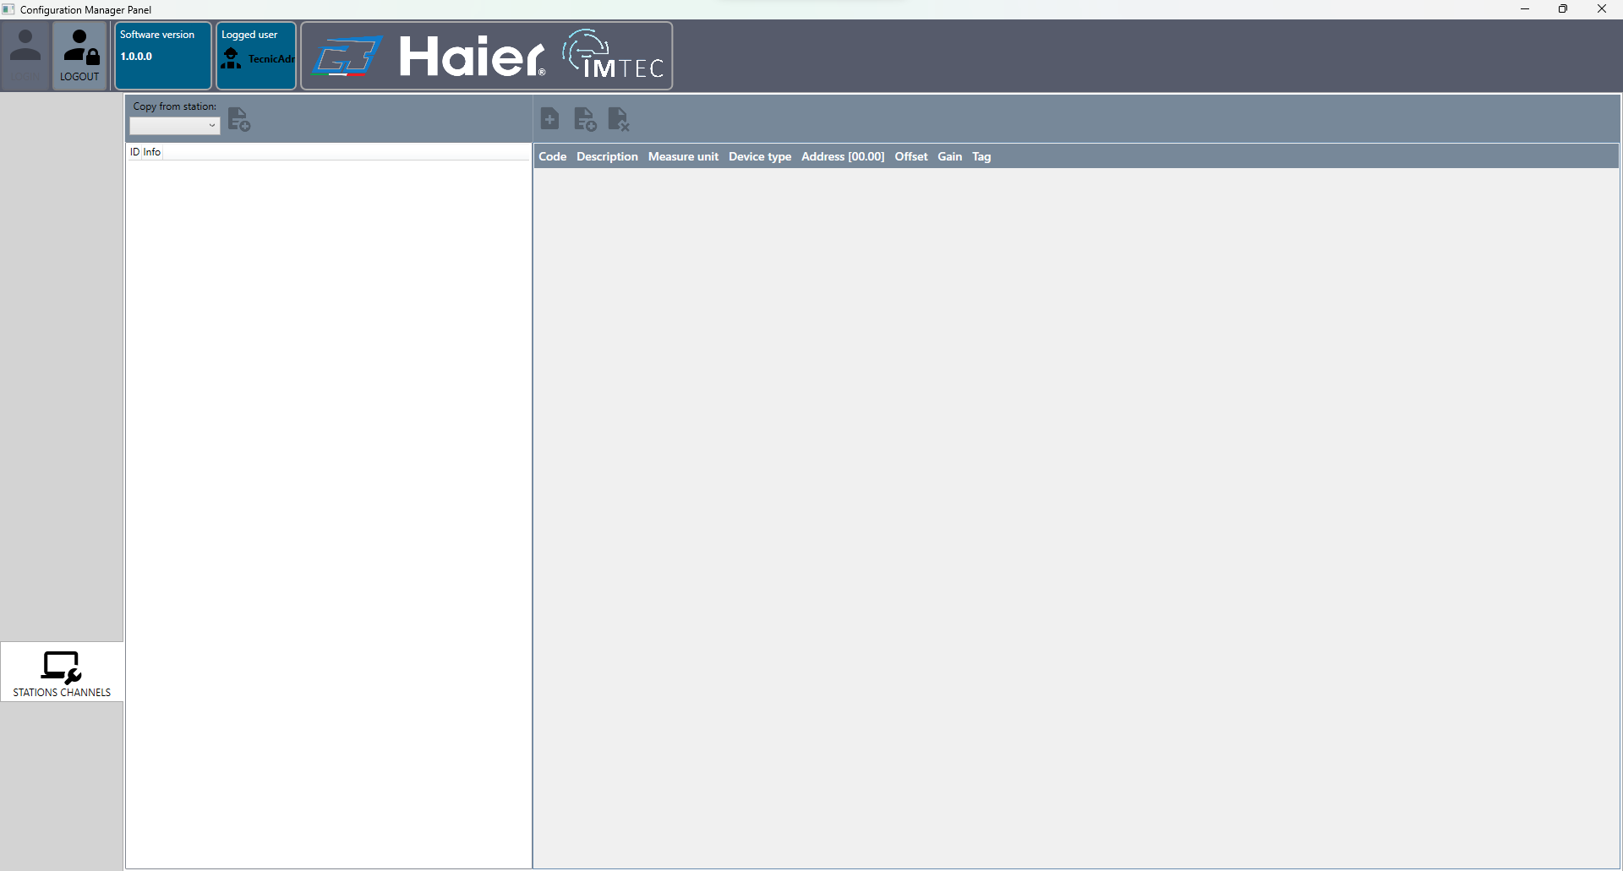
The window is divided into two parts. On the left we have the list of previously created stations, while on the right we have the list of all the channels created.

Copy from station
Below is the function of the buttons on the left panel toolbar:
Icon | Button | Command
Drop-down menu | Copy from station: | Select from the drop-down menu the reference station from which to copy the configuration to the station selected in the list
 | Copy configuration | Copy the configuration of the station selected from the drop-down menu to the station selected in the list
By clicking on the button to copy the configuration a confirmation window appears, to confirm the copy click on the Yes button to cancel the copy click on the No button. If the station selected from the drop-down menu and the station selected in the list are the same, the button will not be enabled.

Station channel management
Below is the function of the buttons on the right panel toolbar:
Icon | Button | Command
 | Edit channel | Opens the window for changing the station channel
 | Copy/Paste Channel | Copy and paste the selected station channel into the list
 | Delete channel | Delete the selected channel from the list

Edit station channel
To edit a station channel, select it from the list and click on the icon to access the following screen:
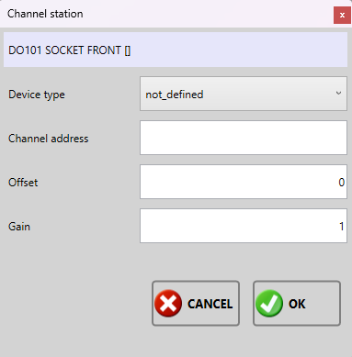
It will therefore be necessary to specify the following data:
- Device type: selective field, select from the drop-down menu which type of device the channel belongs to;
- Channel address : text field composed of two parts dd.cc , replace dd with the device id and cc with the device channel id;
- Offset : Sets an offset for use in mathematical formulas and data processing;
- Gain : Sets a gain for use in mathematical formulas and data processing;
Confirm the changes by pressing the OK key or the Cancel key to cancel them.
<important note>The system is supplied already configured by Marel, the end user does not need to configure any channels</note>

Copy/Paste station channel
Select a channel from the list and click on the icon to copy the channel. Once the channel has been copied, select another channel from the list to be able to paste it. When a channel is pasted, the same creation window opens but with the data of the copied channel. Modify the desired fields and complete the operation by clicking the OK button or cancel the operation by clicking the Cancel button. Once the operation has been cancelled, you need to copy the channel again by selecting it again and clicking on the copy button again.

Delete station channel
To delete a channel, select it from the list and click on the icon this operation resets the type of associated device, the channel address, the offset and the gain. Confirm the deletion by clicking Yes or cancel it by clicking No.

Use of the program: archive management
Let's see the function of the program archive management. The program is used to browse all the tests performed and export them to process the data with third-party software. When the program starts we access the following screen:
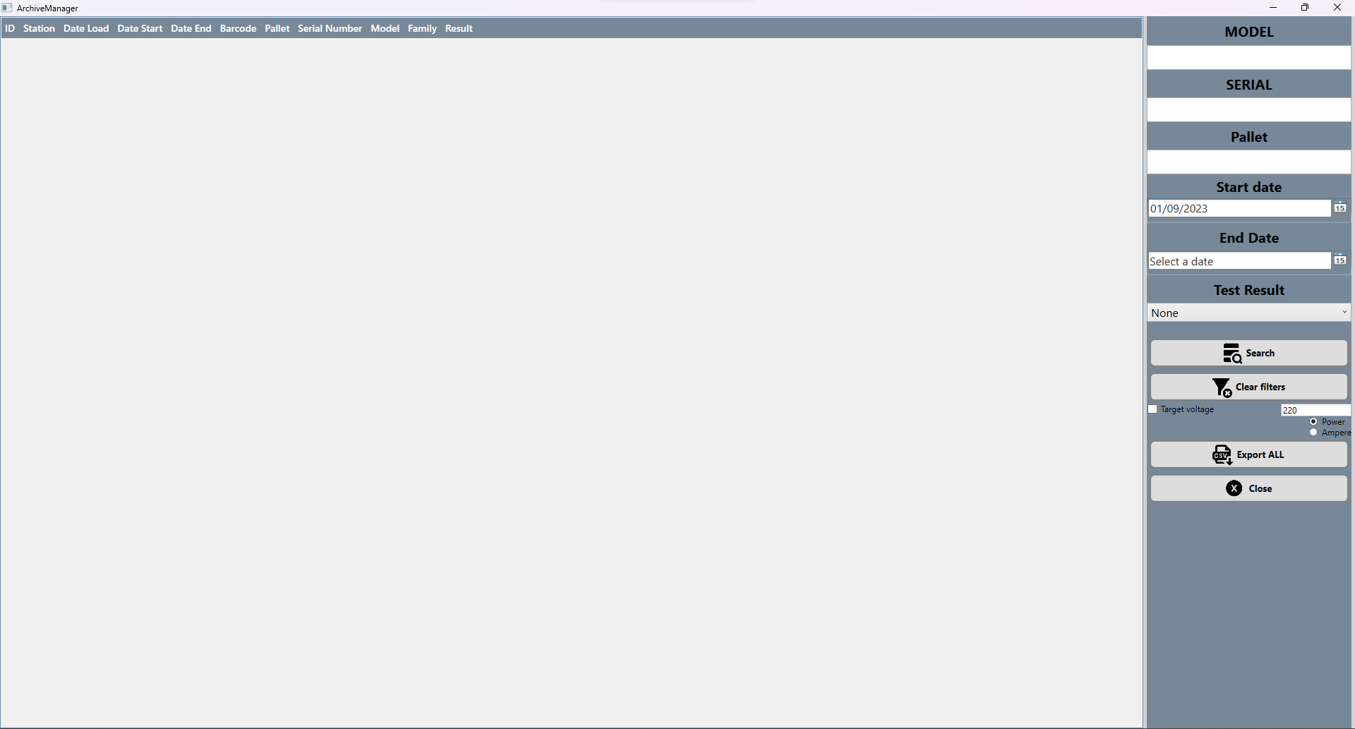
To search for tests performed, fill in the data on the side of the page. As filters we have:
- Model : text field, insert the complete model or part of it
- Serial: text field, enter the complete serial or part of it
- Pallet : text field, enter the complete pallet or part of it
- Start date: date field, select the date from which to start the search, the selected date is included in the search
- End date: date field, select the date from which to end the search, the selected date is included in the search
- Test result : selective field, select the test result to search for
Below is the function of the keys:
Icon | Button | Command
 | Search | Starts the search for tests based on the filters set
 | Reset filters | Reset all set filters
No icon | Reference voltage | Enable the option by clicking in the square and fill in the rectangle with the voltage rating. Sets the voltage rating plate value or recalculates all the values read at that specific voltage during the csv extraction (adding a column)
No icon | Power or Ampere | Selective field, select the type of value to recalculate whether in volts or amperes
 | Export all | Start exporting all selected tests into a single .csv file
 | Close application | Closes the archive management application
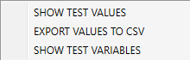
In the list of tests it is possible to open a drop-down menu by clicking with the right mouse button, the options are:
- Show test values: Opens a new window where it shows the values read during the test, all readings;
- Export values to .csv: Exports all selected tests to a .csv file;
- Show variable values: Opens a new window where it shows the values of all test variables.

Show values
Right-click on the test and select show values to access the following screen:
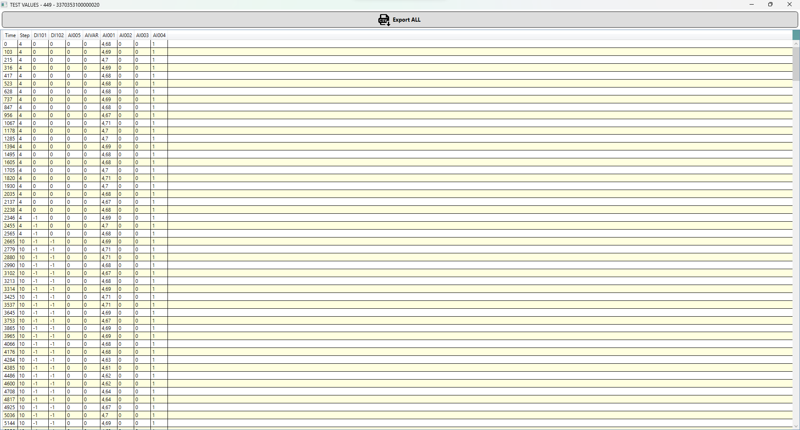
On this screen you can see all the values read during the test. This data is raw without any calculation as it is read by the acquisition devices so it is reported on the screen and can be exported in “csv” format by clicking on the icon {{:icons8:icons8-export-csv-96.png?32|} } Export all.

Show variables
Right-click on the test and select show variables to access the following screen:
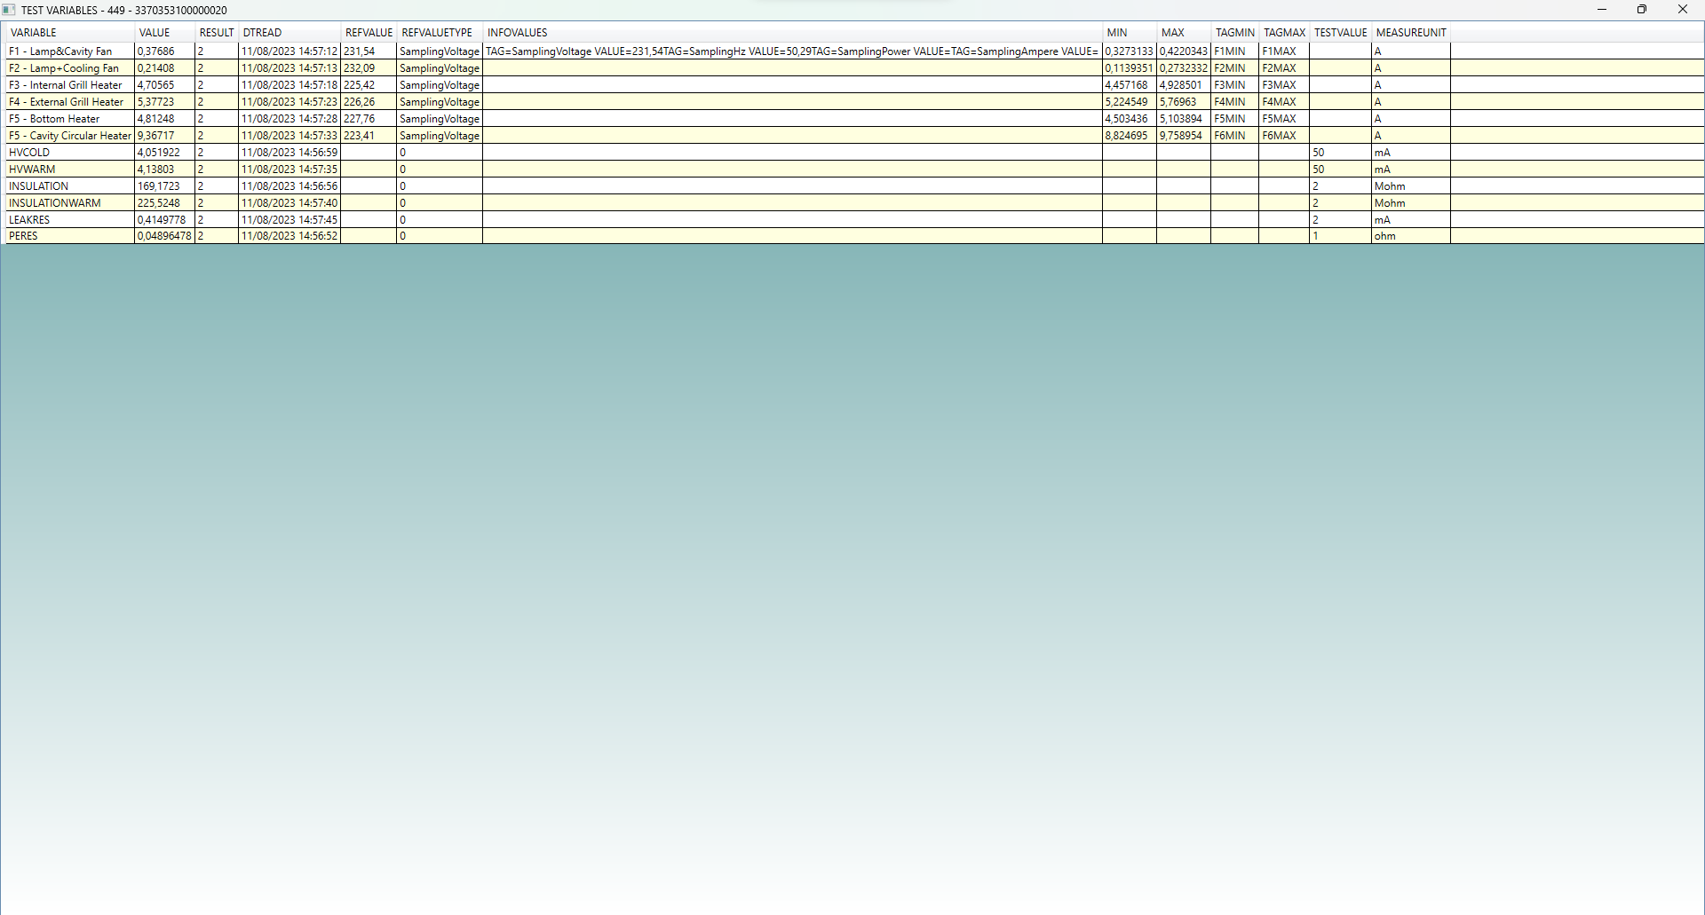
In this screen you can see the test variables during the execution of the process and the value read.

Use of the program: station management
Start the station management program to access the following screen:
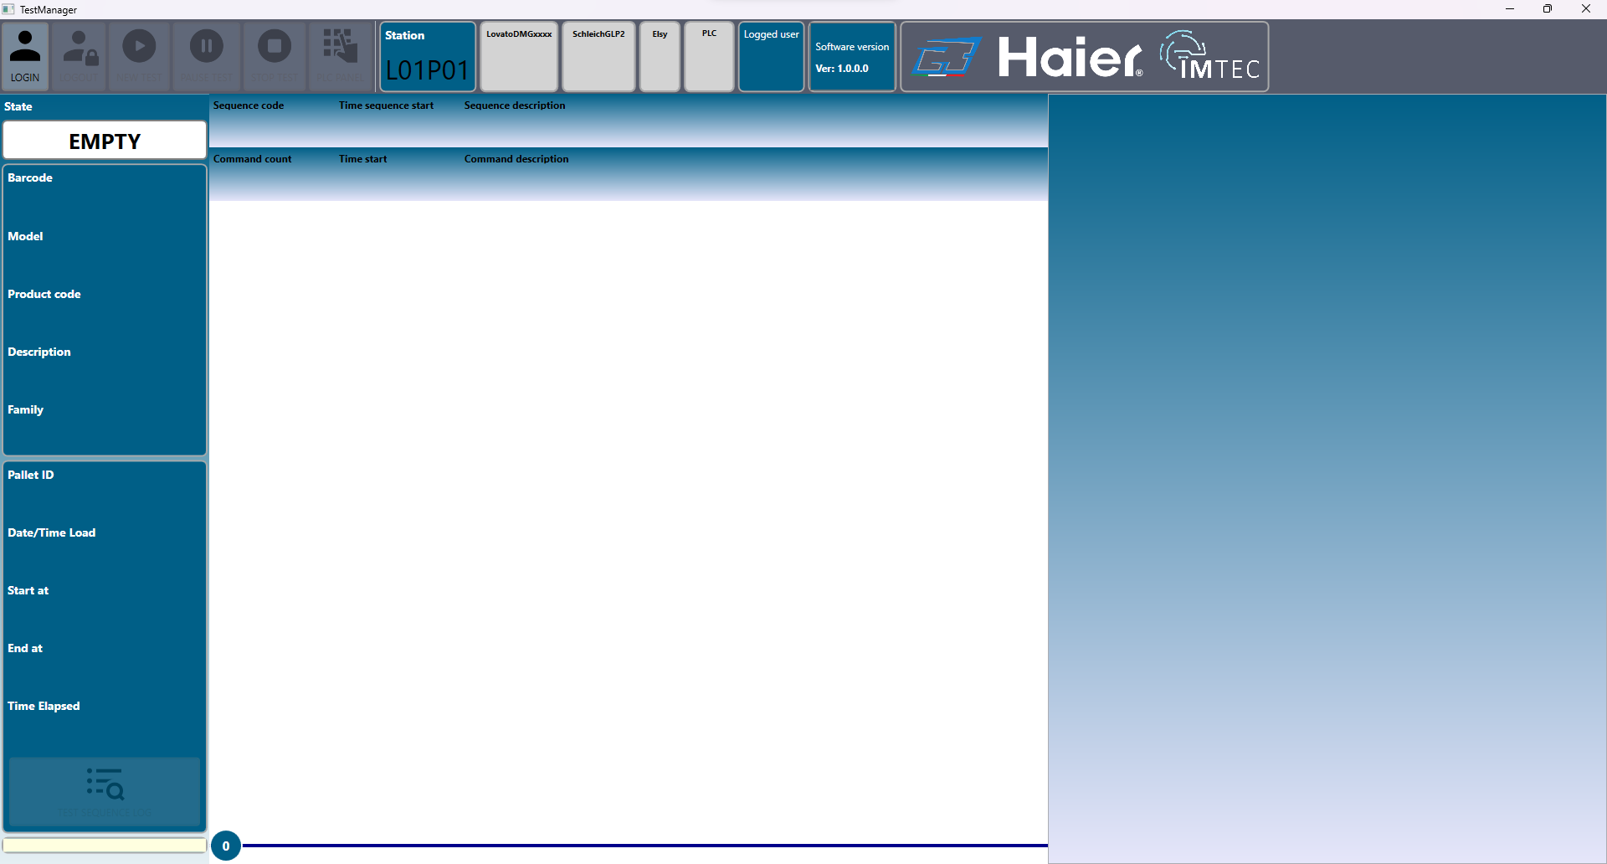
If you enter via the login button with a technical administrator user, the main screen presents more information as follows:
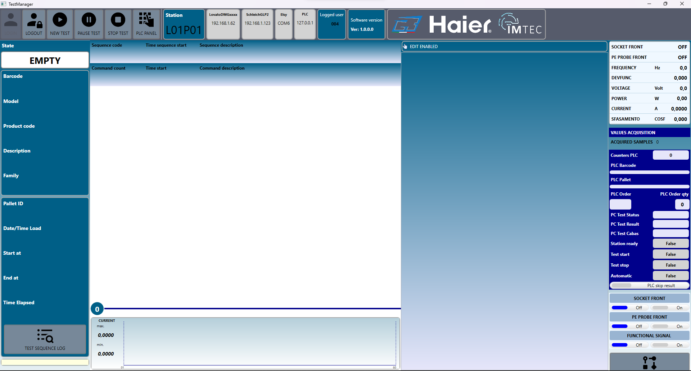
Below is the function of the toolbar buttons:
Icon | Button | Command
 | Login | Opens the login window
 | Logout | Exit from the user
 | New test | Opens the window to create a new test
 | Pause | Pauses the running test
 | Stop test | Stops running test
 | Plc panel | Opens the window to communicate with the on-board PLC
Following the functional keys we also have a block for each device configured in the system and a block for the connected user.
>>>>>>>>>>>>>>>>>>>>>>>>>>>>>>>>>>>>>>>>>>>>>>>>>>>>>>>>>>>>>>>>>>>>>>>>>>>>>>>>>>>>>>>>>>>>>>>>>>>>>>>>>>>>>>>>>>>>>>>>>>>>>>>>>>>>>>>>>>>>>>>>

Nuovo test
Cliccare sull'icona per accedere alla seguente finestra :
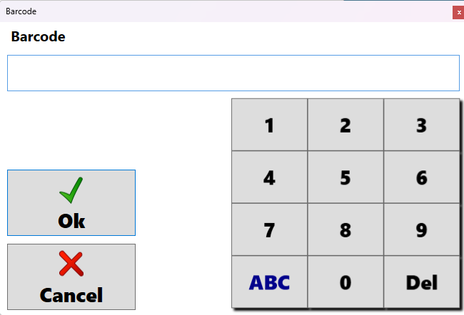
Inserire il barcode del prodotto da testare e premere OK per avviare il test o Cancel per annullare l'operazione.
Nel sistema corrente il test è avviato automaticamente tramite la comunicazione tra PC e PLC

Pausa test
Cliccare sull'icona pausa per mettere in pausa il test in esecuzione appena possibile. Alcuni comandi non possono essere messi in pausa istantaneamente per cui devono essere completati prima di impostare la pausa nel test.

Stop test
Cliccare sull'icona stop per interrompere immediatamente il test in esecuzione. Il test interrotto non puo essere riavviato e quindi è necessario creare un nuovo test.

Pannello PLC
Cliccare sull'icona pannello plc per aprire il pannello con i comandi configurati :
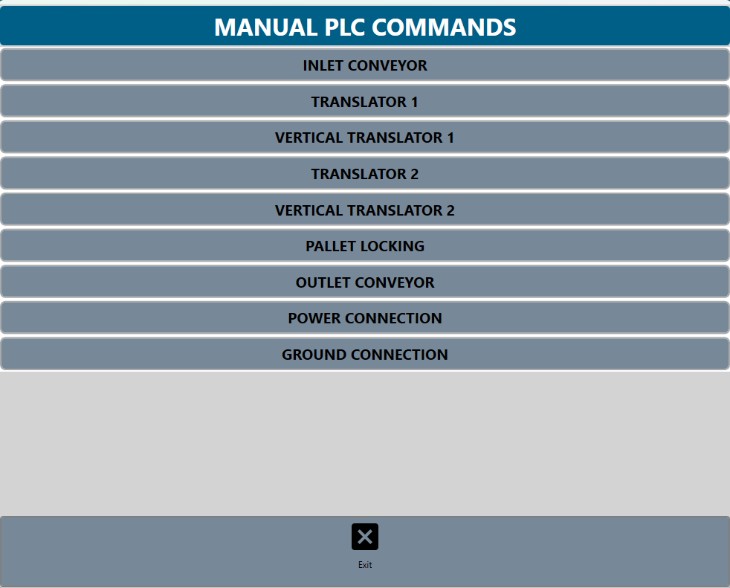
I comandi presenti in questo pannello sono configurati ad hoc in base al sistema ed in base al plc montato

New test
Click on the icon to access the following window:
Enter the barcode of the product to be tested and press OK to start the test or Cancel to cancel the operation.
In the current system the test is started automatically via communication between PC and PLC

Pause test
Click the pause icon to pause the running test as soon as possible. Some commands cannot be paused instantly so must be completed before pausing the test.

Stop test
Click on the stop icon to immediately stop the running test. The interrupted test cannot be restarted and therefore a new test must be created.

PLC Panel
Click on the plc panel icon to open the panel with the configured commands:
The commands in this panel are configured ad hoc based on the system and based on the mounted PLC

